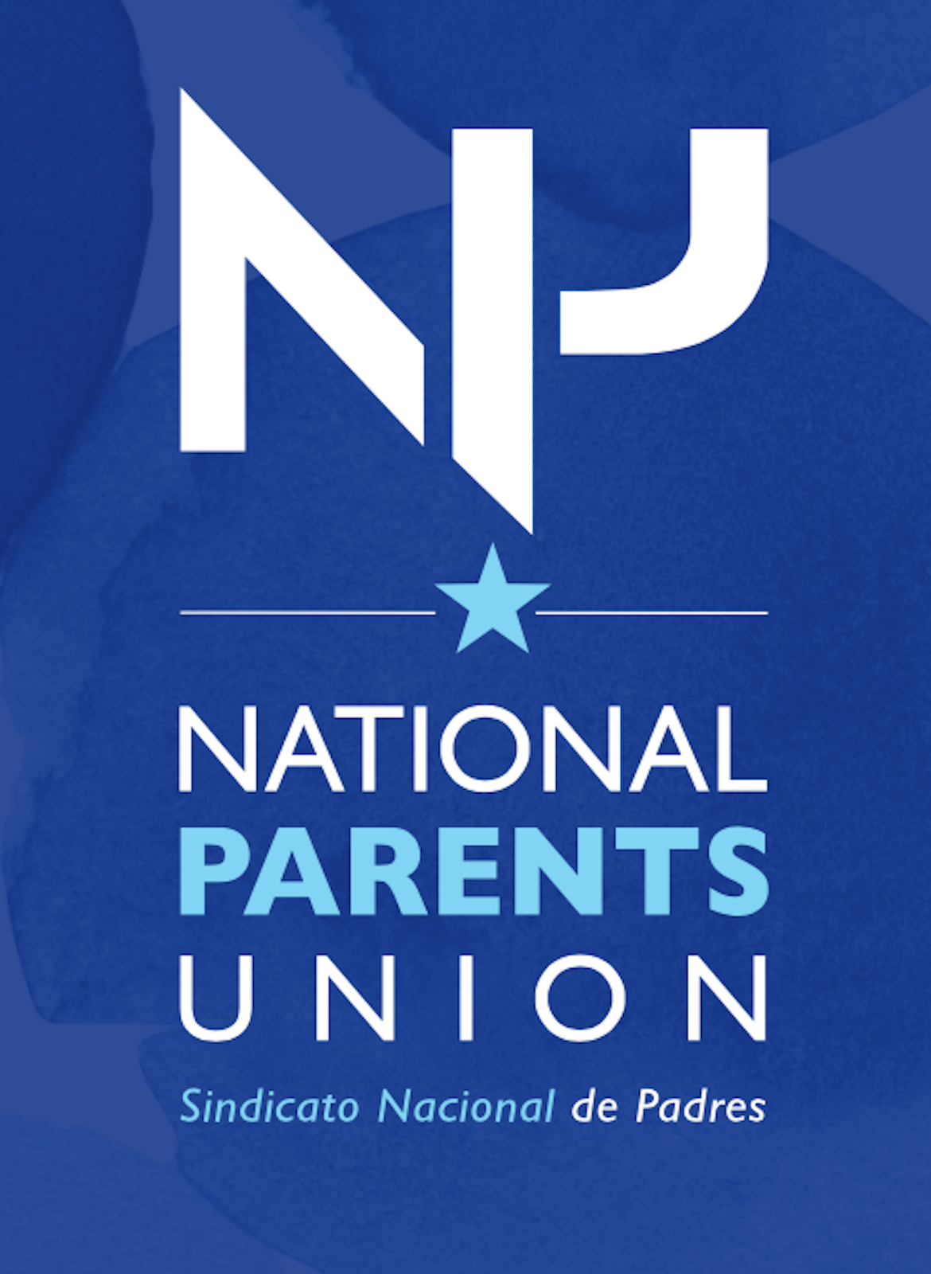

President Donald J. Trump
1600 Pennsylvania Avenue
Washington, DC
20500

October 5, 2020

President Donald Trump and Team:

The National Parents Union is a network of highly effective parent organizations and grassroots activists across the country that are united behind a set of common goals and principles to channel the power of parents. Our family advocates improve the quality of life for children across the United States and define the education narrative and conversation.

Our vast network of organizations and parent leaders representing all 50 states, Washington DC and Puerto Rico unites parents who are engaging, educating and empowering families, neighborhood by neighborhood across the United States.

We believe our children should always be at the core of our agenda in every decision.

We believe there should be liberation, justice, and equity in education for all children.

We believe education systems must be transformed to eradicate generational institutions of oppression.

We believe, families have a powerful voice that should influence educational and political policies and practices at the local, state, and national level. And it is time to forge a path forward to create space to put education at the top of the list of our national priorities.

Access to a high-quality education must be a civil right. Every child should have the civil right to a high-quality, equitable, world class, globally recognized education. To be clear, we are not using the term “civil right” as a metaphor. We believe the time has come to translate “kids first” from a political sound bite into an actionable civil right for every public-school parent and student in America. As discussions ensue over re-imagining public education and school re-openings, it is vital to distinguish between this actionable civil right and already existing compulsory education laws. A high-quality education has not been fully realized and the measurable outcomes from already existing mandates in public education have not been adequate. As schools reopen leaders like yourself will face the choice to either rebuild the status quo ante with all its structural issues ranging from inadequate quality instruction, inequity and institutional racism, or to fully and actually reimagine it for children, especially traditionally ill-served and left behind low-income children and children of color. We urge you to endorse a legal right to a high-quality public education for every child in America and create a legal North Star to guide the reopening process.

Our belief that educational equity is foundational to building a better future for children is shared by the vast majority of public-school parents throughout the nation. What is also shared is the strong understanding that the authentic voices of parents must be included to inform the education landscape in decision making processes. In an ongoing poll conducted nationally, NPU found that establishing a civil right to a high-quality public education is supported by 72% of all public-school parents in America.

We also believe that parents as key stakeholders and primary educators with families and community as major stakeholders in education are well positioned to determine the best education for their children. The sovereignty of parent, family, and community roles are not only in their position as best decision makers to influence the lives and livelihood of their children, but is authority granted in and a direct reflection of our American democracy, values, and freedom. Parent voice is essential in the decision-making process to ensure that any educational system they subscribe to will best suit the needs of their children.

Although this is our belief and mission, history has proven an alternate plan and agenda when it comes to allowing Black and Brown parents an authentic voice and consideration regarding their children’s educations. In order to move forward in the direction of progress and change, the National Parents Union highly recommends the following courses of action be taken regarding education policy:

” Learning outcomes” include all graduation, achievement, and other academic and social-emotional standards promulgated by the relevant State, SEA, or LEA that apply to all or to similar students or schools in the State or LEA.

Representation of authentic parent voice on all education platforms and committees to include but not limited to parent advocates, parents of color, parents of students with disabilities, parents of youths in detention.

Appropriate appointment of US Department Secretary of Education reflective of but not limited to: Cultural congruence with the Black and Brown population, a background and proven track record in education, community engagement, and organizational leadership. These to reflect the inclusion of a diverse background of parents from all walks of life and a proven background also track record in working with these diverse groups of parents on policies and decision making.

Funding demands and an equity plan that moves beyond diversity and inclusion into systemic change reflective of but not limited to: the intent and spirit by which the 1866 and 1964 Civil Rights acts were initiated (to include any amendments), the 1965 Elementary and Secondary Education Act, Title l original creation and usage for marginalized parents to be empowered surrounding advocacy for their children’s education, Title lV fully funded and the expansion of Title VII to include student support/academic enrichment programs that are culturally congruent with ethnically matched providers, Early Childhood Education fully funded with the intent of early intervention that bridges the achievement gap, and respect to the Civil Rights act in decreasing hostile work environments for our Black and Brown educators.

Fully funded special education reflective of but not limited to: Individualized Education Plans (IEPs) that are based on the child’s actual disability needs, externally funded parental support in the SST, 504, and IEP processes, immediate consequences for Free and Appropriate Public Education (FAPE) & Individuals with Disabilities Education Act (IDEA) violations also immediate consequences for violations of federal section 504 which can be heard by the federal courts/government, and removal of bias & cost benefit analysis in the special education process.

Physical education & nutrition guidelines that are monitored by the US Department of Agriculture guidelines and are reflective but not limited to: whole foods, non-processed foods, fresh uncanned fruits & vegetables, sugar & carb limiting food pyramid, and organic meals provision as determined by the American Heart Association and Diabetic Association Nutrition guidelines.

Teacher and leadership training reflective but not limited to: culturally congruent hiring/retention/professional development practices, stringent teacher and leadership evaluations and vetting, knowledge of various modalities of learning, understanding and support of kinesthetic learners, trauma reducing and anti-discriminatory behavior modification plans that take into consideration the school to prison pipeline, also social emotional learning that celebrates world cultures.

College, Career, and Vocational Education pathways reflective of but not limited to: meeting the needs of the demographic per region, equitable regardless of low SES to high SES communities, indicative of the needs in the marketplace/capitalistic economy, removal of barriers and gatekeepers and withholding of opportunities information, fair & monitored grading practices, measurable outcomes driven education, and lowest debt accruing offerings.

Curriculum guidelines that are reflective of but not limited to: Inclusive of Black, Indigenous People of Color’s (BIPOC) perspectives and histories unbiased to the dominant white cultural experience, vetted by parents & community representatives, empowers and equips students to pursue international educational and employment opportunities, also world class subject matter and concepts that triangulate in global competition & innovation.

School safety guidelines that are reflective of but not limited to: reducing zero tolerance practices that unfairly target Black and Brown students; exchanging school police for counselors and culturally congruent engagement events, offering comprehensive wrap around services that are exclusive and not a direct extension of the district/or school attended, reducing bullying and racial hate speech (often referred to as racial slurs & epithets), emergency preparedness reflective of modern day society and dismissive of discrimination and institutional racism, immediate removal of policies and procedures that criminalize the students & parents deferring effective advocacy, also updated school environments that are environmentally safe and conducive to learning.

Fully funded and respected parent choices & options reflective of but not limited to: Homeschooling and public charter schools, Federal funds (ADA) allocated to each pupil to follow that pupil whatever school her/his/their parent(s) deem appropriate for their academic and social-emotional advancement, per pupil spending reflective of student needs and parent demands, money follows the students no matter when they enroll or disenroll from a school, appropriation of funding monitored to ensure that the resources allocated are used for their intended purpose, and public funding used on high efficacy solutions that are brain researched based and driven by highest percentage possible measurable outcomes.

It is our goal at the National Parents Union to ensure that every child has an equitable, high quality education. We believe that education is a mode to freedom from oppression and that the federal government plays an important role in setting the tone. We ask you as a leader and a potential future president to not only seriously consider our requests and recommendations, but also allow us to be parent representatives in your education policy, plan, and decision-making processes.

We are hopeful that you will invite us to the table to continue this important discussion.

Respectfully,
Keri Rodrigues
President
The National Parents Union

Christina Laster
National Parents Council/Delegate, California
Director of Policy & Legislation

Wendy Gonzalez-Neal
National Parents Council/Delegate, Texas

Maritza Guridy
National Parents Council/Delegate, Pennsylvania

Tafshier Cosby
National Parents Council/Delegate, New Jersey

Vivett Dukes
National Parents Council/Delegate, New York

Yahaira Lopez
National Parents Council/Delegate, Massachusetts

Bernita Bradley
National Parents Council/Delegate, Michigan

Christy Joyce
National Parents Council/Delegate, Missouri
Kelley WIlliams-Bolar
National Parents Council/Delegate, Ohio

Khulia Pringle
National Parents Council/Delegate, Minnesota

Judith Yanez
National Parents Council/Delegate, Arkansas

Nehemiah Frank
National Parents Council/Delegate, Oklahoma

Soangelis Rivera
National Parents Council/Delegate, Puerto Rico

